Adv Python for Fin Programming - Group Project

Group D Final Report

Haojia Li, Xinhe Zhang, Zihan You

Covid19 Impact on the Stock Market - Focusing on Apple and Boeing

**Statement of Problem**

From February 2020, the economy and stock markets have been through turbulent change. Almost every industry has been affected. We would like to focus on the stock market’s Beta coefficient and volatility to measure the influence.

We chose 2 sectors, industrial and technology, we thought either being shocked immediately or being influenced in a complicated way.

Industrial sector includes a wide variety of manufacturers and transportation companies. Both industries were immediately and especially affected by COVID-19. Travel ban and 14 days self-quarantine policy reduced the fleet dramatically. In the U.S, commercial transportation activity to and from the airports had an average decreased in volume of 44%. The sudden change reduced the revenue of transportation companies such as Boeing and made the finance experience an unexpected shortfall. And that shortfall will last longer because people will change their traveling plans and patterns out of their concerns and lockdown policy in different countries.

The Manufacturing industry is also one of the most impacted industries. Around 80% of manufacturers have admitted that the pandemic will impact their revenues. Because most manufacturing workers can’t work remotely, isolation orders stopped plants from operating immediately. Another reason is that the pandemic slowed down the economy and reduced the demand for products. Some manufacturers rely on debt obligation to operate the product line and cash flow, this pandemic will make them enter bankruptcy.

As for the technology sector, things are more complicated.

On one hand, COVID-19 did hurt the industry’s growth. Not only the containment efforts stifled innovation, which is one of the most important elements of the technology sector, but also the earlier outbreak in China influenced the supply chain. For example, Apple experienced shortages on its supply as a result of Foxconn, the company's primary manufacturer, shutting down its production in China.

On the other hand, this is an opportunity for technology companies to redirect their strategy and accelerate their development rate. Because of the isolation order, people began to explore more dimensions of virtual office. The coronavirus could highlight possible use cases for virtual reality in enterprises. Technology industry has focused on virtual offices a few years ago. This pandemic could be the impetus for more companies to use VR and other extended reality tools.

The COVID-19 also reminds us of the importance of smart city solutions in crisis management. How to examine the body temperature effectively, how to help citizens to do self-testing. This is an important domain for technology sectors.

We collected S&P 500 data of 11 sectors during the period before and after COVID-19. And calculated the Beta coefficient. The numbers in Figure1 are Beta before the pandemic, compared with numbers in Figure 1, which are Beta after the pandemic.

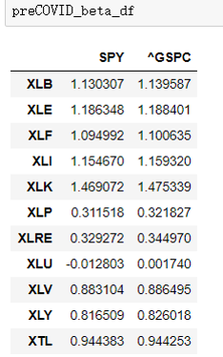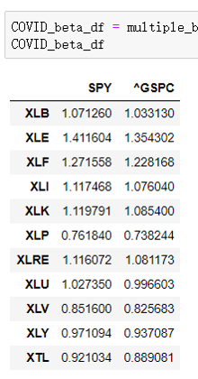

Figure 1 - Beta pre covid and during covid

For a more detailed and direct display of the processing results, we calculated the differences between two sets of datas. (Figure 2)

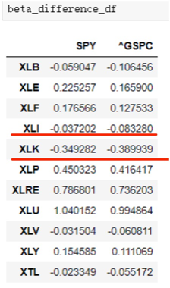

Figure 2 - Beta difference

As we can see in Figure 2, the betas are more negative for both technology and industrial sectors. That change brought our attention. Based on the analysis about the economic environment above, we presuppose that industrial sectors beta will be influenced significantly and the systematic risk will increase dramatically. So we selected the industrial sector to be a representative sector for our report.

The change for the technology sector is like a foregone conclusion. Because of the promising prospect of the industry, we decided to study the change of this sector at the first beginning.

**Approach to Problem**

To generalize how deeply the COVID-19 impacts the stock market of two chosen sectors. We selected two companies as representatives, Apple for technology and Boeing for industrial. We calculated and compared Beta coefficients during different periods before and after the COVID-19.

Beta coefficient can measure the volatility of a stock compared to the whole stock market. It can describe the relationship between systematic risk and expected return for stocks. Investors can use it to gauge the risk added to a stock and reconsider the investment plan for portfolios.

To draw the conclusion from the view of the whole picture and give a more systematic and comprehensive outcome, we calculated and compared standard deviation and daily stock market jump as another dimension of stock’s volatility. The daily stock market jump was obtained from collection and assessment of stock’s daily move data. That index can outline the stability of stock for us.

With all the data, we analyzed pre-COVID versus this year. For example, how did the std-dev of returns, daily stock jump and Betas change between last year and this year. By doing so, we draw a blueprint of how this pandemic influences the stock market environment and the structure of the economic and financial market.

**Model**

Linear regression is the main model that applied in this report. Linear regression model is used to calculate the beta value of the stocks. Beta is a measure of the volatility of a security compared to the market as a whole. Beta is also known as a measure of systematic risk. In this report, the dependent variables are the stock returns of Apple and Boeing companies. And the independent variables are the returns of their related sector ETF and index, including Technology Select Sector SPDR Fund, Industrial Select Sector SPDR Fund, SPDR S&P 500 ETF Trust, and S&P 500 Index.

Another thing worth noticing is the timeline selection. We have chosen the timeline from Feb 18 ,2020 to Jun 30, to identify the influence on Beta coefficient and stock’s Volatility caused by COVID-19.

Feb 18 is the first trading day of the third week in February. Since this paper was written by Jun 30, we chose the date as the ending day.

The actual outbreak happened on Feb 23, more than 79,000 cases of Covid-19 found in 29 countries. The S&P 500 plunged for the first time on the same day. That brought the investors’ attention to reconsider the virus’s impact carefully.

But during the week before Feb 23, investors and the markets largely ignored the outbreak in China during January. On Feb 11 and 12, global markets rose to a high record on encouraging signs that the infection rate of Covid-19 might have plateaued in China. An investor survey conducted by the DataTrek Research collected between Feb 18 and 22 found that most investors still believe Covid-19 will not cause a global economic recession, and only about one-third of them had made changes to their portfolios, taking into account the risks of the disease.

We think Feb 18 is a good standpoint to observe and compare the change because the decline of the economy and break of supply chain in China has begun to influence the American economy and stock market. But most investors didn’t take it seriously. We didn’t choose Feb 24 as the beginning because after the first plunge all of investors have taken steps, actively or passively. But as the survey showed, some of them have already changed portfolios from Feb 18.

In the visualization part, line charts are the kind that most often used. Line chart is used to depict the daily adjusted close price, return, and volatility change in the datetime order. Besides, heatmap is another useful approach to visualize data. It is used to show the beta difference between pre-COVID-19 and CVID-19 periods. Additionally, a grouped bar chart is applied to depict the beta difference before and during COVID-19 of Apple and Boeing companies against S&P 500 index.

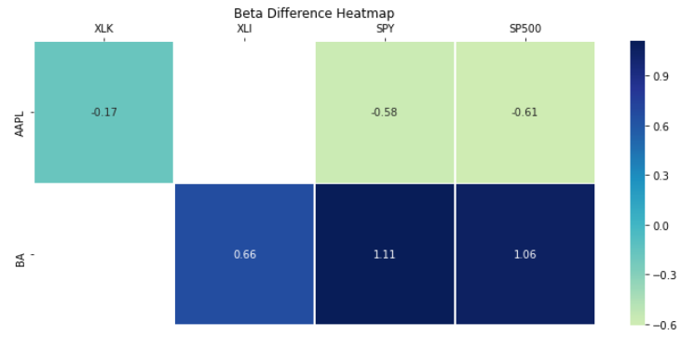

Figure 3 - Beta Difference Heatmap

Figure 3 is a heat map whose color according to beta difference. Figure x shows that Boeing company experienced a big positive beta change while Apple company’s beta value decreased. Beta is the measurement of systematic risks which can not be avoided. The whole market experienced huge change due to the COVID-19. The decrease of Apple company’s beta, whatever it is against, shows that Apple is more stable and it is not sensitive about the change made by COVID-19. On the opposite, Boeing company fluctuated much more violently than the market even its sector.

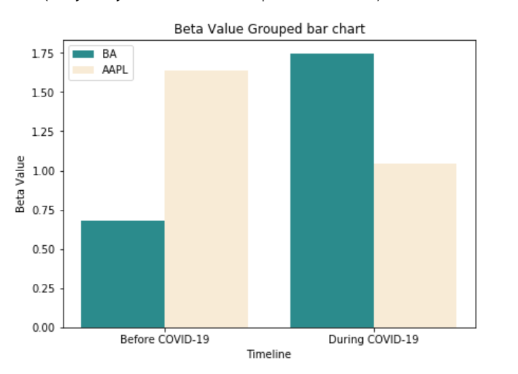

Figure 4 - Beta value grouped bar chart

Figure 4 is a grouped bar chart of betas before and during COVID-19. The betas here are calculated by companies’ return against S&P 500 return. Figure y depicts the great changes of beta directly. Like figure x, figure tells us that COVID-19 has a huge impact on Boeing company. However, Apple's company suffers little from infectious disease.

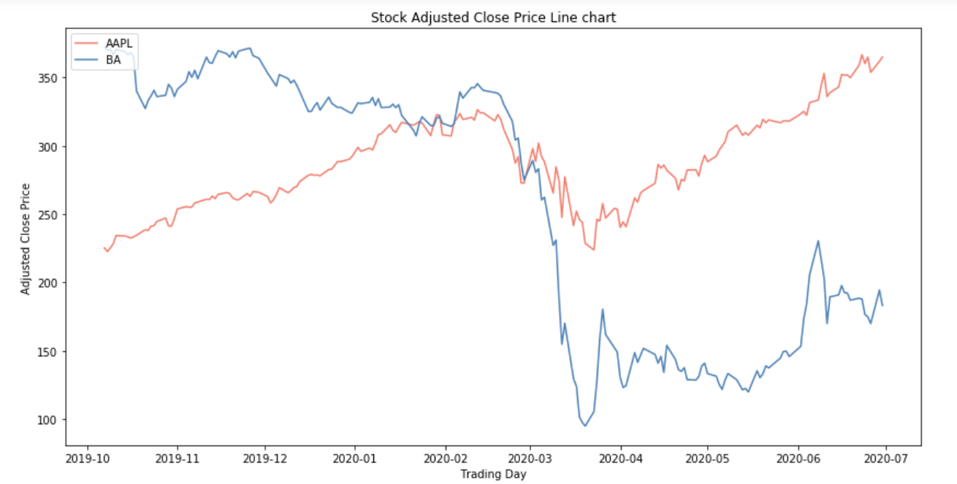

Figure 5 - Stock adjusted close price line chart

Figure 5 is a multiple line chart of adjusted close price of Apple and Boeing. The vertical dashed line in the middle of the graph represents the date we chose as the start of the COVID-19. Figure z shows that both Apple and Boeing decreased after the COVID-19 striked. But Apple soon rose again and kept rising in the past three months. Boeing incurred a big loss and is hard to recover. Boeing is suffering, which identifies with the implications from figures above.

**Data**

Our main data collected included the opening price and adjusted daily closing stock price of 2 stocks, which are Apple and Boeing Company. Additionally, stock data for S&P 500, Tech sector (e.g. SPDR XLK) and Industrials sector (e.g. SPDR XLI) will be included for further analysis. We also collected SPDR S&P 500 Trust ETF (e.g. SPY) for reference.

The stocks data was collected from Alphavantag, "<https://www.alphavantage.co/query>" by requests package. For the S&P 500, Tech sector, and Industrials sector, the data was collected from Yahoo Finance, “<https://finance.yahoo.com/>”.

The original data was collected for 2 companies, S&P 500, XLK, and XLI separately. Taking Apple as an example, the original data file has 5032 rows (20 years) and 8 columns, which are open price, highest price, lowest price, close price adjusted for splits, adjusted close price adjusted for both dividends and splits, volume, dividend amount, and split coefficient.

**Implementation**

We made three ipython notebooks totally in this project. To verify our intuition about technology and industry field, we made a “sector_selection (with comments).ipynb'' to compare the beta values of pre-COVID-19 and COVID-19 periods and the changes of eleven sectors. In the “Group D 3.1 (with comment).ipynb”, we mainly collected data from various sources and neatened them. After that, we applied linear regression between several variables and calculated the beta before and under COVID-19. Last but not least, “volatility changes.ipynb” was designed to compare the volatility changes in the stock market before and after COVID-19 happened.

The required packages are requests, os, dotenv, pandas, matplotlib, statsmodels.

In the sector selection python notebook, the raw sector ETF data are from Yahoo finance in the form of csv. It is too much data to obtain if we use web services like Alpha Vantage. It is possible that we reach the daily limit of the api and thus that we may not do the following analysis. To calculate the beta value of pre-COVID-19 and COVID-19 periods, linear regression is the main statistical model that we used in this python notebook. The dependent variables here are select sector SPDR funds, such as “XLK”, “XLI”. And the independent variables here are SPDR S&P 500 ETF trust and S&P 500 index, their symbols are “SPY” and “^GSPC '' respectively.

The second python notebook we developed is the “Group D 3.1 (with comment).ipynb”. In the first part of the ipython notebook, we obtain stocks and funds data from the Alpha Vantage web service. We quote a function called “FormDailyRequestData” from the lecture material to form requests. After that, we request stocks and funds prices whose symbols are AAPL, BA, SPY, XLK, XLI from Alpha Vantage, and succeed. We need more than 100 days’ data, so the “output_size” here is “full.” We then put data into variables whose names combined with their symbols and “_raw”. The S&P 500 index data are from Yahoo Finance. In the second part, we read “S&P 500 data from .csv”, and sorted the data as above.

In order to process our data for later use, we developed a class called “COV19_DATA”. It requires three inputs, they are raw dataframe, start date, and end date. It can execute several methods about processing data before and during COVID-19.

The first main method is to sort the data in time order and return a dataframe containing only daily adjusted close prices and returns. We found that all data from the Alphavantage were in the type of string. So, we designed a function called “sorted_adjclose_return” to change the type of the data. We change date data to timestamp and price data to float. We took the date and adjusted close columns to make new dataframes, set date as the index, and calculated daily return according to adjusted close price. Lastly, it will return the sorted dataframe.

The second main method is to find the closest trading date, regarding both start date and end date. We designed two methods “initial_trading_day” and “last_trading_day” that could find initial and last trading dates within the sorted dataframe by moving the date backward to fit the date in the sorted dataframe processed above.

The third main method “COV19_adjclose_return” is a combination of two methods above. We slice the sorted dataframe between the initial trading date and last trading date. The sliced dataframes are the return of this method.

Similar to the second and third methods mentioned above, we designed main methods for pre-COVID-19 period too. They are “PRE_initial_trading_day”, “PRE_last_trading_day”, and “PRE_adjclose_return”. Specially, the pre-COVID-19 last trading day is the trading day before the COVID-19 initial trading day. And the pre-COVID-19 initial trading day is calculated by pre-COVID-19 last trading day minus the days between COVID-19 initial trading day and last trading day.

The last main method of our class is to calculate the standard deviation of returns of COVID-19 and pre-COVID-19 period. They are “COV19_return_std” and “PRE_return_std”.

After the concept design, we put data into the class to do analysis in the fourth part. We choose 2020-02-18 as the start of COVID-19 and 2020-06-30 as the end date of our project. The reason for choosing these dates is in the report’s model part.

Applying the class, we are able to get the standard deviations of Apple and Boeing before and under COVID-19 easily using “COV19_return_std” and “PRE_return_std” methods in the fifth parts of this ipython notebook.

In the sixth part, we applied linear regression between stocks and their related sector fund or index, and got the beta values that we wanted. It is meaningless to apply linear regression between Apple and the industry sector ETF, so that we could see two NaN in the beta dataframe. We made three beta dataframe at the end of the sixth part. They represent betas during COVID-19, betas before COVID-19 and the beta differences between pre-COVID-19 and COVID-19.

We made some visualizations in the seventh part. They are heatmap depicting the change of beta values of Apple and Boeing companies’ returns against related sectors’ ETF returns, grouped bar charts depicting the change of beta before and during COVID-19, and multiple line charts depicting the adjusted close price of Apple and Boeing companies in our target time period.

In the “volatility changes.ipynb” notebook, we studied and compared the changes in stock market fluctuations before and after the covid-19. First of all, we use the historical data of S&P 500 stocks downloaded on yahoo finance to calculate the daily price variation in the stock market with the maximum value of the stock minus the minimum value, and calculate the percentage change. In order to quantify this study, we used 2.5% as the division criterion. The day where the daily volatility percentage is greater than or equal to 2.5% will be defined as jump days. Regarding the setting of this division standard, we have referred to a paper by the National Bureau of Economic Research.

We mainly completed two parts of work. The first part is to compare the number of jump days before and after the covid19. Since the total number of days is almost the same, we selected 95 days before the outbreak and 94 days after the outbreak, so this comparison is in line with common sense. The second part is that we drew time series graphs for the volatility of the stock market. We separately drew the volatility change in the stock market after covid19 and the comparison before and after the epidemic.

**Results and Conclusions**

In order to study the impact of covid19 on the US stock market, roughly speaking, the main results of our project are the return of Apple and Boeing stocks, the standard deviation of the return before and after covid19, the Beta value of two stocks relative to their sectors and S&P500 before and after covid19, and the volatility change in S&P500 before and after the crisis. Next, we will elaborate one by one on what conclusions we can draw through these results.

Judging from the standard deviations of the two stocks, we found that the standard deviations of the returns of the two stocks during the period of covid19 were significantly greater than those before covid19. This result tells us that covid19 has affected the volatility of both companies’ stocks. After the virus crisis, the volatility of both Apple and Boeing’s stocks increased significantly. At the same time, we also found that Apple's standard deviation is smaller than Boeing, which shows that covid19 has a greater impact on the volatility of Boeing's stock.

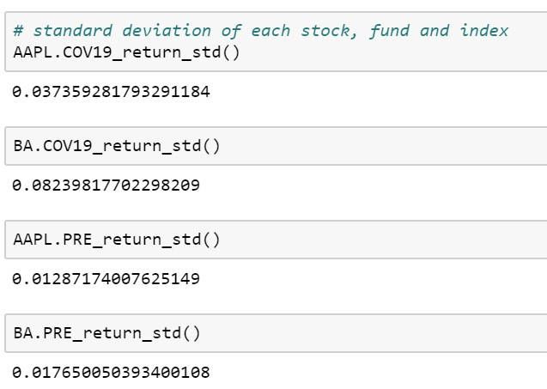

Figure 6 - Standard deviation of each stocks

Then, the beta coefficient is a statistical concept, which reflects the systematic risk performance of an investment object relative to the market. If a firm's market beta from such a regression is equal to 1, it indicates that, on average, the firm's stock returns covary identically with returns to a market wide portfolio, indicating that the firm has the same degree of systematic risk as the market as a whole. If market beta is greater than 1, the firm has a greater degree of systematic risk than the market as a whole. If market beta is less than 1, the firm has less systematic risk than the market as a whole.

From the table of beta, we found that the beta calculated for each industry sector is relatively smaller than the value for S&P 500. We thought that it may be because the correlation between them is greater.

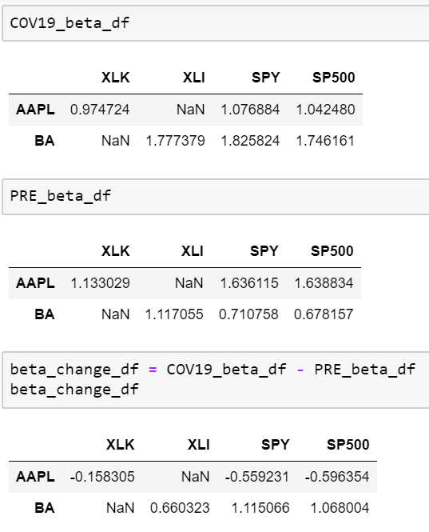

Figure 7 - Table of Beta

At the same time, by comparing the changes in the beta value of the two companies before and after covid19, especially through the table of beta_change_df, we found that the changes of the two companies are not the same. Apple’s overall beta value has decreased, while Boeing’s beta value has increased.

We can conclude that the beta value of Apple's stock is negative, indicating that the stock has changed less than the overall market. Boeing, on the other hand, after covid19, the beta value of this stock became larger, indicating that its range of change is greater than that of S&P500. Specifically, Apple’s beta changed from 1.64 to 1.04 after the outbreak, which is closer to 1, indicating that it had a higher systemic risk than the market and now it is closer to the market’s systemic risk. The beta of Boeing's stock has changed from 0.68 to 1.75, indicating that it has changed from a systemic risk that is smaller than the market to a higher systemic risk than the market, which is a big change. In our situation, beta calculation is a relative concept, and S&P500 and both stocks have received varying degrees of influence from covid19.

We also found an interesting phenomenon. The beta of the industrial sector, where Boeing is located, has not changed much before and after covid19. It has changed from 1.159 to 1.076, with a decrease of 0.08. But Boeing's beta has changed a lot. We think this is because airlines are indeed facing great difficulties during covid19, but the entire industrial sector has other manufacturing companies besides airlines. Perhaps these companies have not been affected so much.

When we looked at the comparison of the number of jump days before and after covid, we found that during the period from October 2019 to mid-February 2020 that we selected, no day's stock market volatility was more than 2.5%. However, when shifting to the covid period, from the end of February 2020 to the end of June, there are a total of 39 days of jump days and 55 days of non-jump days. The number of days with daily volatility greater than 2.5% accounted for 41.5% of the time. From this we conclude that covid-19 has indeed brought great volatility to the US stock market. The number of days that the US stock market experienced large fluctuations during the covid period was much higher than usual.

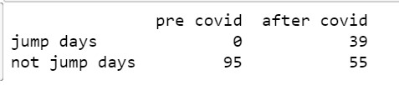

Figure 8 - Jump day table

In order to further present our conclusions, we have drawn a line chart of the stock market volatility for two time periods, and we have placed two lines in one graph. With this graph, we can see that during the covid period, especially in February and March, the overall volatility value of the US stock market is greater than before covid.

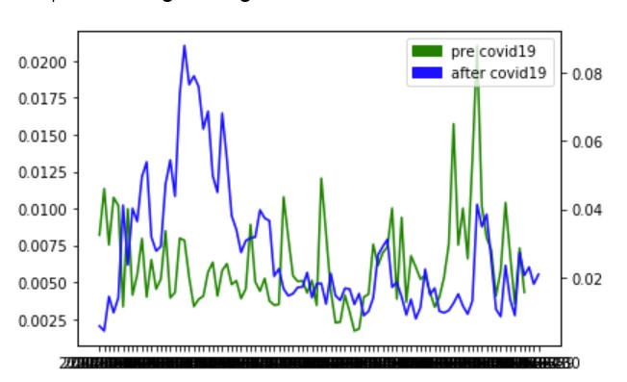

Figure 9 - Volatility change pre & after covid19

Additionally, we also found that the market volatility is consistent with the results of the standard deviation of the return of the two companies, that is, they have generated greater volatility because of covid19.

**Lessons Learned**

Through this group project, we have gained a lot of experience and have a deeper understanding of Python language. By combining Python with finance, we learned how to use python to process financial and stock market big data. By using Python to collect and analyze financial data, we can think more clearly and develop our own ability to understand changes in the stock market. Python's trends and data visualization provide us with more information about the structure of the US stock market. Step-by-step learning of python using help us to comprehend the combination of data processing and finance market operating. We will use python to deal with financial problems more proficiently in future projects.

In addition to the practice of financial knowledge related to python and the stock market, we also learned how to quantify people's intuitive feelings, prove intuition with various kinds of evidence, and discover new interesting findings. We will continue to have this spirit in future projects.

**Reference**

<https://www.vox.com/business-and-finance/2020/2/24/21150798/coronavirus-covid-19-stock-market-dow-sp500-global-economy-china>

<https://www.washingtonpost.com/business/2020/02/28/12-days-that-tanked-markets/?arc404=true>

<https://www.pwc.com/us/en/library/covid-19/coronavirus-impacts-industrial-manufacturing.html>

<https://www.geotab.com/blog/impact-of-covid-19/>